**Week 2 blog post**

**Topic -**

Week 2 – Getting started with UIkit and swift.

Two apps created in week 2 – Light Lamp app and Calculator app.

**Snapshots of final product – (Light Lamp app)**

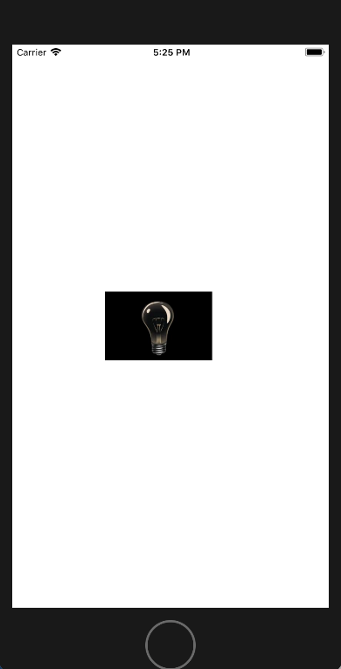

Fig 5: Snapshot of initial simulator view of the app (light off mode) after

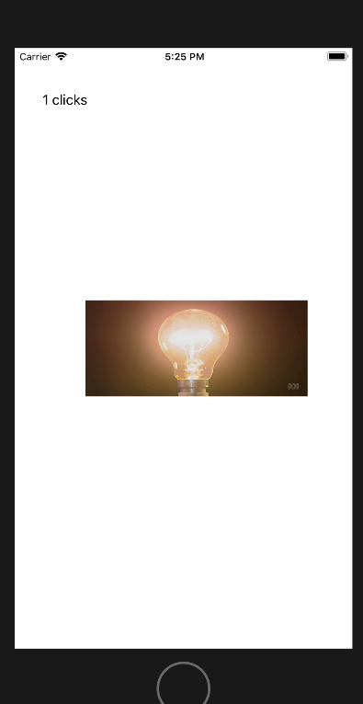

Fig 6: Snapshot after tapping on the light image(light On mode)

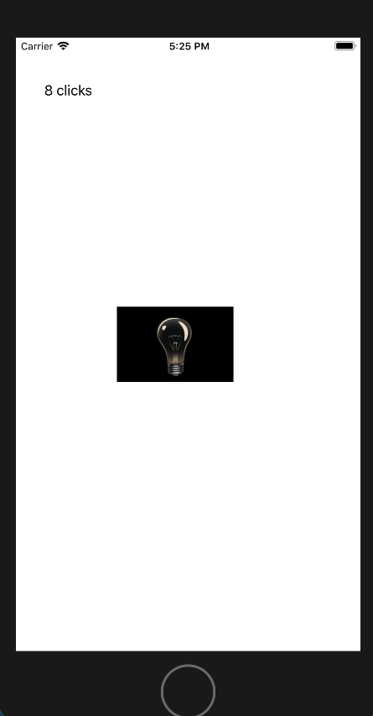

Fig 7: Snapshot depicting the number of clicks functionality(after 8 taps).

**How I implemented – (Light Lamp app)**

For the light lamp app. First thing was to get two images of light on and off mode and add it to assets file. Once I had the images in the main story board I added a button and a label. A button with the initial image of the light off mode and had to set a tag value for the same and the label for showing the number of taps that the user has attempted.

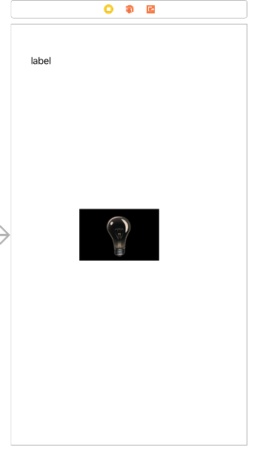

Fig 8: The main screen storyboard of the app

With the help of the tag value the images are set, every time the user clicks the tag value changed and the image with the desired tag value is displayed and a counter variable keeps counting the number of taps on the screen so that it could be displayed in the top label. The following image shows the main function lightOnOff that is responsible for the image change after every time the user taps the button image.

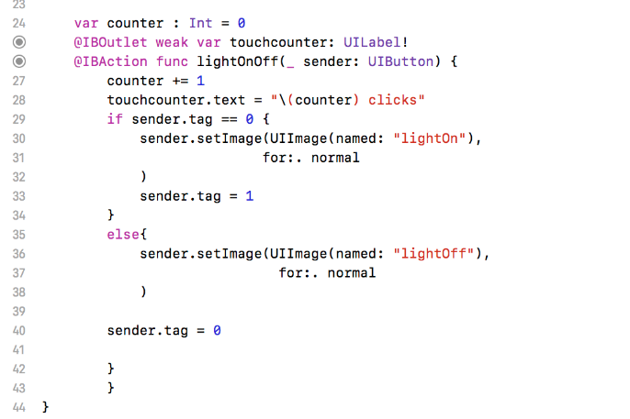

Fig 9: A snippet of the main function of app.

**Snapshots of the final product – (Calculator app)**

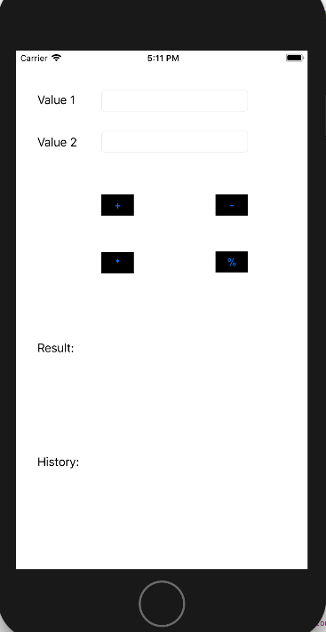

Fig 10: Initial simulator View of the app.

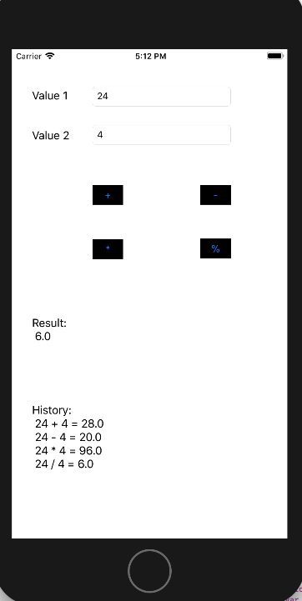

Fig 11: Final View of the app after user entered values in the app.

**How I implemented -**

The calculator app required lot of buttons, labels and text fields. After adding everything on the main story board screen I had to connect the labels and all the operator buttons had separate functions for their functionality as shown in the images.

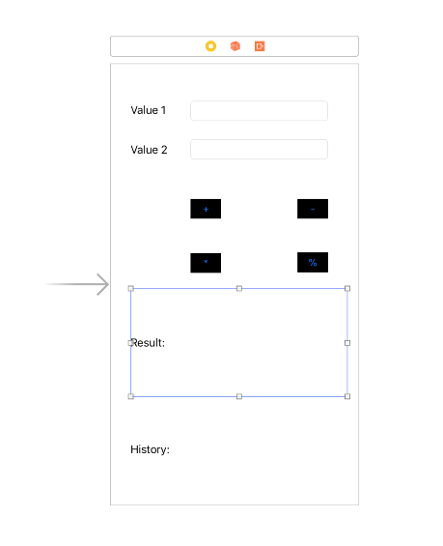

Fig 12: Snapshot of the main story board screen.

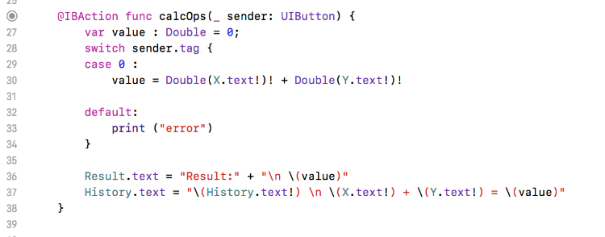

Fig 13: Code snippet of the add function.

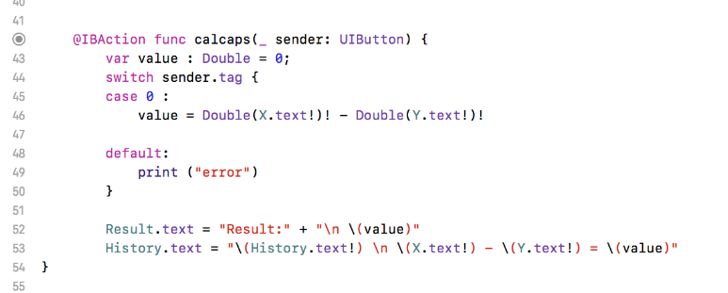

Fig 14: Code snippet of the subtract function.

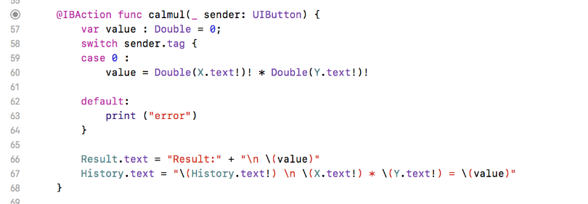

Fig 15: Code snippet of the multiply function

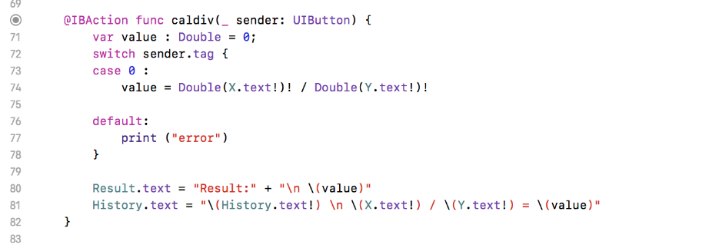

Fig 16: Code snippet of the division function

**Reflection –**

Overall week 2 was really exciting as I developed my first app. Initially it was difficult to under certain variables and functions. Specially the tag feature which is very important as we kept using the tag function for the coming weeks. Week 2 was the stepping stone for the future weeks. The light lamp app was my first experience with app development and I got to learn a lot from this simple app. I got to learn how buttons and labels are connected and how tags are set on buttons. The sender.tag function is one of the most important function that I take back from week 2. Building the calculator app was also very helpful as it involved a lot of work and I had to be careful with the code. Initially I was getting a lot of errors but as I worked through I got to learn at every step. After completion of the lab tasks I started to work for my assignment 1 as I had gained enough knowledge to start with the tic tac toe project, like adding images in the assets folder, creating the layout and adding buttons to the main storyboard screen.